UNIVERSITATEA POLITEHNICA BUCUREȘTI

FACULTATEA DE AUTOMATICĂ ȘI CALCULATOARE

DEPARTAMENTUL CALCULATOARE

|  |  |
| --- | --- |
| upb | cs |

PROIECT DE DIPLOMĂ

NavTask

Instrument de gestionare a sarcinilor și activităților în mediul Android

Ionuț-Vlăduț Pasat

**Coordonator științific:**

Șl. Dr. Ing. Carmen Odubășteanu

BUCUREŞTI

2024

UNIVERSITY POLITEHNICA OF BUCHAREST

FACULTY OF AUTOMATIC CONTROL AND COMPUTERS

COMPUTER SCIENCE DEPARTMENT

|  |  |
| --- | --- |
| upb | cs |

DIPLOMA PROJECT

NavTask

Task and activity management tool for the Android environment

Ionuț-Vlăduț Pasat

**Thesis advisor:**

Sl. Dr. Eng. Carmen Odubășteanu

BUCHAREST

2024

**Table of Contents**

Sinopsis 5

Abstract 5

Acknowledgements 6

1 Introduction 7

1.1 Context 7

1.2 Problem Statement 7

1.3 Study Objectives 8

1.4 Paper Structure 9

2 Requirements Analysis and Specification 10

2.1 Motivation 10

2.2 Methodology 10

2.3 Survey Results and Insights 11

2.4 List of Functionalities 16

3 Market Study/Existing Approaches 17

3.1 Existing Solutions 18

3.2 Limitations of Existing Solutions 19

3.3 Common and Unique Features of NavTask 19

3.4 Comparative Analysis 20

3.5 Opportunities and Areas for Improvement 20

4 Proposed Solution 21

4.1 Description of the Solution 21

4.2 Process of Solution Development 30

5 Implementation Details 32

5.1 Firebase Integration 32

5.2 Notification Handling 33

5.3 Database Setup 36

5.4 Maps and Weather API Integration 38

5.5 Bottom Navigation Bar 39

5.6 Image Picker 40

5.7 Polyline Rendering 41

6 Results Evaluation 43

6.1 Correctness Evaluation 43

6.2 Performance Evaluation 44

6.3 Deployment Strategy 45

7 Conclusion 47

7.1 Summary of the Project 47

7.2 Relevance and Quality of Results 48

7.3 Future Developments 48

8 Bibliography 50

9 Appendices 53

# Sinopsis

Managementul timpului implică planificarea și supervizarea eficientă a alocării orelor zilnice pentru a atinge obiectivele dorite. Provocările apar deseori în urma subestimării duratei sarcinilor, chiar și atunci când acestea au mai fost finalizate anterior, și din faptul că persoanele nu respectă planurile lor de gestionare a timpului. Acest proiect își propune să abordeze aceste probleme prin dezvoltarea unei aplicații. Aplicația va servi ca un instrument de amintire și mapare, conținând diverse informații și utilitare destinate a facilita procesul de împlinire al scopurilor, dar și posibilitatea de personalizare care face aplicația să aibă o interfață mai prietenoasă. Prin materializarea și vizualizarea acestor obiective, utilizatorii pot identifica eventuale priorități și pot face ajustări necesare în programul lor pe baza datelor observate. [1]

Cuvinte cheie: managementul timpului, motivație, aplicație, prioritate, planificare.

# Abstract

Time management involves effectively planning and overseeing the allocation of one's daily hours to achieve desired objectives. Challenges often arise from underestimating task durations, even when completed previously, and individuals are not adhering to their time management plans. This project endeavours to address these issues through the development of an application. The application will serve as a reminder and mapping tool, aligning a diversity of information and tools gathered to facilitate the process of fulfilling one’s goals. Users can identify specific priorities and adjust their schedules based on the observed data by materialising and visualising these objectives. [1]

Keywords: time management, motivation, application, reminders, scheduling.

# Acknowledgements

I want to express my deepest gratitude to my parents, whose unwavering support and provision enabled me to pursue my studies at this esteemed university. Their belief in me has been a constant motivation throughout my academic journey. I am also profoundly thankful to my thesis advisor for their invaluable guidance and insightful advice, which have been instrumental in shaping this thesis. Additionally, I extend my heartfelt thanks to all my teachers and colleagues, whose continuous encouragement and assistance have helped me grow and improve each day. Your contributions have been vital to my success, and I am truly grateful for your support.

# Introduction

## Context

Time management is a critical skill that involves planning and exercising conscious control over the amount of time spent on specific activities, mainly to increase effectiveness, efficiency, and productivity. It stretches over a vast range of practices, tools, and techniques used to manage time when accomplishing specific tasks, projects, and goals. [1] Effective time management allows individuals to prioritise tasks, set achievable goals, and reduce stress, leading to a more balanced and productive life. By organising and planning how to divide time between various activities, one can work smarter, not harder, ensuring that more tasks are completed in less time, even when time is tight and pressures are high. [2]

## Problem Statement

The need for time management is paramount in today's fast-paced world, where balancing work, education, and personal life can be challenging. Without proper time management, individuals may struggle with procrastination, miss deadlines, and experience increased stress and burnout. Effective time management helps to improve focus, enhance decision-making skills, and achieve a sense of accomplishment. [3] As Stephen R. Covey eloquently puts it in his book, "The 7 Habits of Highly Effective People," "The key is not to prioritise what’s on your schedule, but to schedule your priorities." This highlights the importance of aligning one's tasks and goals with their core values and priorities, ensuring that the most important tasks will be addressed first. [4]

In the realm of academic and professional development, time management is essential. As emphasised by David Allen in his book, "Getting Things Done: The Art of Stress-Free Productivity," a systematic approach to managing tasks can lead to increased efficiency and reduced stress. Allen's methodology underscores the significance of capturing all tasks and commitments in a trusted system and processing them in a structured manner. This approach helps not only manage daily tasks but also set and achieve long-term goals. [5]

The project addresses the common challenge of efficiently managing daily tasks and schedules. Many individuals struggle with organising their responsibilities and completing them on time. The difficulty in keeping track of what needs to be done, where it needs to be done, and under what conditions can lead to disorganisation and missed deadlines. By providing a platform to log tasks, along with contextual information such as weather conditions and travel directions, the application helps users better prepare and manage their daily activities.[2]

## Study Objectives

The primary objective of this project is to develop an Android application that enhances users’ time management capabilities by offering a user-friendly platform for logging tasks, scheduling them effectively, and providing contextual utilities such as weather updates and navigation assistance. By addressing common time management challenges, this solution aims to facilitate better daily planning and execution of tasks, leading to improved productivity and reduced stress for users.

Specifically, the objectives are to:

* *Provide an Intuitive Task Logging and Scheduling Tool*: The application allows users to log tasks for specific days, helping them organise and plan their activities efficiently. This feature aims to make task management straightforward and accessible, enabling users to keep track of their responsibilities and deadlines.
* *Offer Contextual Information*: The app adds practical value to the task management process by integrating weather updates for task locations and providing directions from the user’s current location to the task site, the app adds practical value to the task management process. These utilities help users prepare better for their tasks, considering environmental conditions and travel requirements, thus reducing the uncertainty and inconvenience associated with daily planning.
* *Enhance User Experience with a User-Friendly Interface*: The application is designed with a focus on ease of use, ensuring that users can quickly navigate and utilise the app's features without a steep learning curve. This objective aims to increase user adoption and satisfaction by providing a seamless and enjoyable experience.
* *Promote Effective Time Management Practices*: By offering tools that help users log, schedule, and execute tasks efficiently, the app encourages the adoption of effective time management practices. This can lead to improved organisation, better prioritisation of tasks, and more efficient use of time, which are crucial for both personal and professional growth.

The project’s resolution expects to lead to several significant developments:

* *Increased Productivity*: Users will benefit from a more organised approach to managing their daily tasks, leading to increased efficiency and productivity.
* *Improved Task Preparation*: With weather updates and location-based directions, users will be better prepared for their tasks, reducing last-minute disruptions and enhancing task execution.
* *Enhanced Planning and Execution*: The integration of task scheduling with contextual information will provide users with a comprehensive tool for planning their day, ensuring that all relevant factors are considered in their task management process.
* *Greater User Engagement*: The app's user-friendly interface and valuable features are anticipated to drive higher user engagement and satisfaction, leading to broader adoption and a loyal user base.

Ultimately, this project aims to deliver a robust solution for time management that not only addresses existing challenges but also provides users with the tools and insights needed to achieve their goals more effectively.

## Paper Structure

This paper is organised into several sections to systematically present the project and its outcomes.

* *Introduction*: Discusses the importance of time management and provides an overview of the project’s relevance and purpose.
* *Requirements Analysis and Specification*: Defines the specific needs the application addresses and the functionalities it must include based on a conducted survey.
* *Market Study / Existing Approaches*: Examines current solutions and tools for task management and how they compare to the proposed application.
* *Proposed Solution*: Details the design and main features of the application, including task logging, weather forecasts, and navigation assistance.
* *Implementation Details*: Describes the technical implementation, including the development process and the technologies used.
* *Results Evaluation*: Evaluate the application's performance through user testing and feedback, assessing its effectiveness in real-world scenarios.
* *Conclusions*: Summarize the key findings, discuss the impact of the application, and suggest potential areas for future development.
* *Bibliography*: List the sources and references that informed the research and development of the application.
* *Appendices*: Provide additional documentation, screenshots, and supporting material relevant to the project.

# Requirements Analysis and Specification

This section examines the product's required features from the viewpoint of prospective users and anticipated usage situations. The objective is to compile a list of functionalities essential for developing a product that satisfies the needs and expectations of users. The analysis draws upon data gathered through a Google Form survey, pinpointing current challenges and desired functionalities in a time management application.

## Motivation

The primary motivation for developing a time management application with a user-friendly interface integrated with weather and mapping services stems from the survey results, which highlight several challenges faced by users in managing their tasks effectively. Many respondents reported issues such as forgetting tasks or deadlines, poor task prioritisation, lack of reminders or notifications, and difficulty accessing information on the go. These pain points indicate a need for a comprehensive solution that not only helps users organise and prioritise their tasks but also provides relevant context and information to facilitate task completion.

Integrating weather and location-based services can significantly enhance the user experience by providing real-time weather updates and directions for task locations. This added functionality can help users better plan their activities and make informed decisions based on environmental conditions and travel times, ultimately improving their time management and productivity.

Furthermore, the survey results reveal a strong interest among users for such integrated features, with many respondents expressing a positive or very positive attitude towards incorporating weather and mapping services into their time management applications.

## Methodology

A survey was conducted using Google Forms[3] to gather user requirements and insights. The survey consisted of multiple-choice and open-ended questions designed to capture participants' demographic information, their current time management practices, challenges faced, and desired features in a time management application.

The survey reached a targeted audience of individuals aged 20-24 years, representing the primary user group for the proposed application. The responses were collected over a period of time and compiled for analysis.

## Survey Results and Insights

### Importance of time management

According to the chart in Figure 2‑1 below, the majority of respondents, 51.7%, consider time management to be "Very important" in their day-to-day activities. This suggests that effective time management is a crucial aspect for a large portion of the surveyed individuals, potentially due to various factors such as busy schedules, multiple responsibilities, or a desire to optimise productivity.

The second-largest group, totalling 37.9% of respondents, perceives time management as "Important." While not as critical as the "Very important" group, this segment still recognises the value of proper time management practices in their daily

routines.

A smaller portion of the respondents, 10.4%, either have a neutral stance on the significance of time management or do not consider it an essential aspect of their daily lives.

Overall, the chart highlights that an overwhelming majority (89.6%) of the surveyed individuals consider time management to be important or very important in their day-to-day lives. This finding underscores the need for effective time management solutions and justifies the development of a time management application that can cater to the needs of users who value efficient organisation and utilisation of their time.

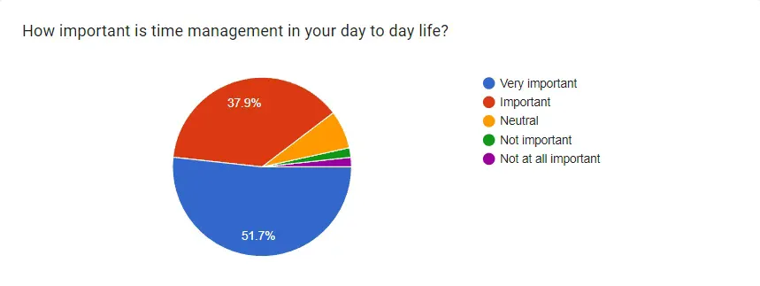

Figure 2‑1 Time Management Importance

### Currently used time management methods

According to the chart in Figure 2‑2, the largest segment, comprising 37.9% of respondents, relies on "Mental Tracking," which involves remembering tasks without the use of formal tools or applications. This approach may be convenient for individuals with a strong memory or those who prefer a more informal method of time management.

Additionally, 24.1% of respondents indicated using "Digital Tools" exclusively, such as apps, software, or online calendars. This group likely values the convenience, accessibility, and organisational capabilities provided by digital solutions for time management.

This consolidated view highlights the substantial demand and preference for digital solutions among the target audience. It reinforces the importance of developing a time management application that can effectively cater to this sizable segment of users who rely on digital platforms for organising their tasks and schedules.

Factoring the people who said they are using mental tracking as their primary method of monitoring day-to-day tasks and their level of satisfaction extracted from the form[4], we can pronounce that mental tracking, while convenient for some, can become increasingly challenging as the number of tasks, deadlines, and commitments increases. It places a significant burden on an individual's memory and can lead to forgetting important tasks or deadlines, as evidenced by the survey results where "Forgetting tasks or deadlines" was cited as a significant challenge. [6]

This data underscores the importance of developing a time management application that caters to a wide range of user preferences and potential integration with existing tools or methodologies. By offering a versatile solution that can seamlessly incorporate various time management practices, the proposed application can effectively address the needs of a broader user base.

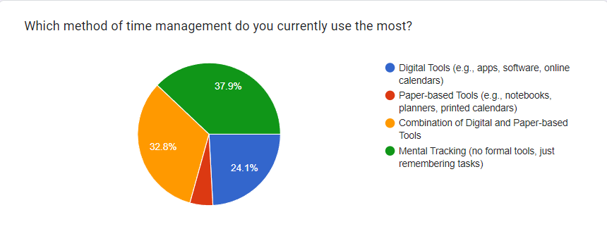

Figure 2‑2 Time Management Methods

### Time management app usage

The pie chart in Figure 2‑3 represents the frequency at which survey respondents use time management or to-do list apps.

The largest segment, comprising 36.2% of respondents, indicates using time management or to-do list apps on a weekly basis. This suggests that a significant portion of the surveyed group has incorporated these tools into their regular routines, likely finding them helpful for organising and managing tasks on a recurring weekly cycle.

The second-largest group, accounting for 27.6% of respondents, reports rarely using such apps. While they may have experimented with or explored time management applications, their infrequent usage could indicate dissatisfaction with existing solutions or a preference for alternative methods of task management.

Another sizable segment, 20.7% of respondents, use time management or to-do list apps daily. This group likely finds these applications indispensable for their day-to-day task management needs, relying heavily on the organisation and reminders provided by the apps.

Overall, the data suggests a diverse range of usage patterns, with a significant portion (56.9%) of respondents being regular users (daily or weekly) of time management or to-do list apps. However, there is also a considerable segment (27.6%) that rarely uses such applications, indicating potential room for improvement or a need for more compelling solutions.

This information can guide the development and marketing strategies for the proposed time management application. By addressing the pain points of infrequent users and offering a user-friendly, feature-rich solution, the application may attract a broader user base, including those who currently rely on alternative methods or have been dissatisfied with existing options.

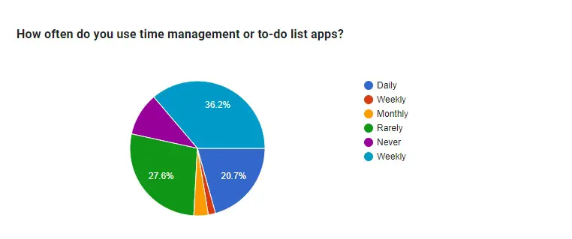

Figure 2‑3 Time Management App Usage

### Desired features

The bar chart illustrated in Figure 2‑4 presents the features that survey respondents find most useful in a time management app. By analysing the data, we can gain insights into the essential functionalities users expect from such an application.

The topmost desired features are:

* Reminders and notifications (50 responses, 86.2%): A vast majority of respondents value the ability to receive reminders and notifications for upcoming tasks, deadlines, or events. This feature helps users stay organised and ensures they don't miss important commitments.
* Task scheduling (49 responses, 84.5%): The capability to schedule and organise tasks is considered highly useful by a significant portion of respondents. This functionality allows users to plan and prioritise their activities effectively.
* Location-based services (e.g., directions) (11 responses, 19%): While not as highly demanded as the top two features, a considerable number of respondents find location-based services, such as directions to task locations, useful in a time management app.
* Weather updates for task locations (13 responses, 22.4%): Receiving weather updates for task locations is seen as a valuable feature by a smaller but notable segment of respondents. This information can assist in planning activities and adjusting schedules based on weather conditions.

This data aligns with the proposed development of a time management application that incorporates features like task scheduling, reminders, location-based services, and weather updates. By prioritising the implementation of these highly desired functionalities, the application can effectively cater to the needs and preferences of the target user base, potentially leading to higher adoption and satisfaction rates.

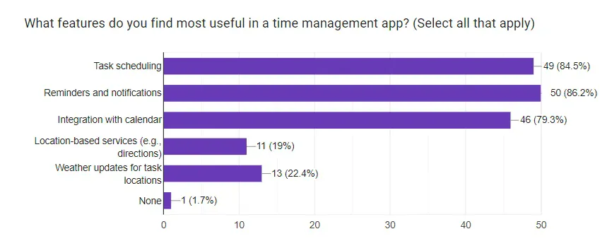

Figure 2‑4 Useful App Features

### Task types

The bar chart in Figure 2‑5 illustrates the types of tasks that survey respondents most frequently manage using an app or would like to manage if they started using one. By analysing the data, we can understand the diverse task categories that potential users seek to organise and prioritise through a time management application.

The most prevalent task types are

1. Academic assignments: A significant majority of respondents indicate a need to manage academic assignments using a time management app. This highlights the application's potential usefulness for students juggling various coursework and deadlines.
2. Work-related tasks: Managing work-related tasks is another critical requirement for many respondents, suggesting that the app could cater to professionals or those with employment responsibilities.
3. Personal errands: A substantial portion of respondents express a desire to manage personal errands or tasks using the app, showcasing its potential for organising day-to-day activities beyond work or academic commitments.
4. Social activities: While not as prevalent as the other categories, a considerable number of respondents indicate an interest in managing social activities through the time management app.

This data underscores the need for the proposed time management application to cater to a diverse range of task types, including academic assignments, work-related tasks, personal errands, and social activities. By offering a comprehensive and versatile solution, the application can effectively address the varying needs of its potential user base, encompassing students, professionals, and individuals with diverse responsibilities.

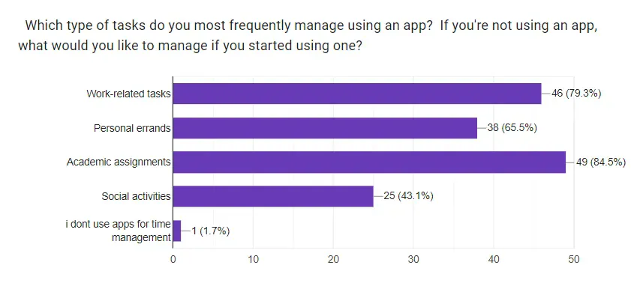

Figure 2‑5 Most Common Task Types Managed Using an App

### Task prioritisation

The chart illustrated in Figure 2‑6 displays how people typically prioritise their tasks based on different factors. According to the data, the largest portion (50%) prioritises tasks according to urgency or deadlines. This suggests that a significant number of people consider time constraints and due dates as the primary factors when deciding which tasks to tackle first.

The second-largest segment (29.3%) prioritises tasks based on importance or impact on goals. This indicates that many people also consider the significance and potential consequences of tasks when determining their priority.

Additionally, 12.1% of respondents prioritise tasks based on convenience or ease of completion, while 8.6% consider the time available for the task.

The data clearly shows that urgency, importance, and time constraints are the top factors people consider when prioritising tasks. This supports the development of a time management app with features like task scheduling, reminders, and integration with weather and maps APIs. Such an app could help users effectively prioritise tasks based on deadlines, importance, and time availability, while also providing relevant location and weather information to aid in task planning and execution.

By catering to the evident need for task prioritisation based on urgency, importance, and time constraints, and offering additional context like weather and directions, the proposed app could potentially enhance user productivity and task management capabilities.

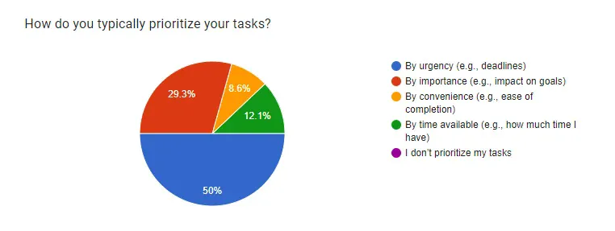

Figure 2‑6 Task Prioritization

## List of Functionalities

Effective time management is crucial for individuals juggling multiple responsibilities and commitments in their daily lives. [7] The proposed time management application aims to provide a comprehensive solution that not only streamlines task organisation and scheduling but also incorporates context-aware features to enhance the overall user experience. By integrating location-based services and weather updates, the application seeks to address the diverse needs and expectations of students, professionals, and individuals managing personal tasks, travel plans, or event coordination.

Based on the survey results and the identified use cases, the following functionalities are deemed essential for the proposed time management application:

### Task Management

* Creation, editing, and deletion of tasks or to-do items
* Assignment of due dates and times for tasks
* Prioritization or importance levels for tasks (e.g., high, medium, low)
* Ability to add task notes or descriptions for additional details

### Reminders and Notifications

* Setting reminders for tasks and events
* Push notifications for upcoming tasks and reminders

### Location-Based Services

* Integration with mapping services (e.g., Google Maps)
* Retrieval of directions and travel times to task locations
* Automatic detection of the user's current location

### Weather Integration

* Provision of weather updates for specific task locations

### Task Prioritization and Sorting

* Sorting of tasks based on due dates, priorities, or categories

### User Interface and Experience

* Clean and intuitive user interface
* Secure user authentication

This comprehensive list of functionalities addresses the diverse requirements and preferences expressed by the survey respondents, catering to the needs of students, professionals, and individuals managing personal tasks, travel plans, or event coordination. The integration of location-based services, weather updates, and calendar synchronisation aligns with the proposed vision of a time management application that provides context-aware information and seamless integration with external services, enhancing the overall user experience and facilitating effective time management across various domains.

# Market Study/Existing Approaches

This section provides a comprehensive analysis of similar time management applications available on the market. The goal is to identify their limitations, the types of users they serve, and the gaps these products leave unaddressed. Additionally, this section will highlight the unique features of our application, how it stands out from the competition, and any areas where further improvements are needed.

## Existing Solutions

Several time management and to-do list applications dominate the market. Here, we will compare three popular apps: Todoist, Microsoft To Do, and Google Keep. Each of these apps has distinct features and caters to different user needs.

### Todoist*[5]*

Features: Task creation and organisation, project management, labels, filters, reminders, integrations with other apps.

Target Users: Professionals, project managers, individuals with advanced task management needs.

User Ratings: Generally high, praised for its powerful features and integrations, but noted for its steep learning curve.

### Microsoft To Do*[6]*

Features: Task creation, due dates, reminders, file attachments, integration with Microsoft Office.

Target Users: Microsoft Office users, individuals seeking basic task management.

User Ratings: Positive, especially among Microsoft users, but criticised for lacking advanced task management features.

### Google Keep*[7]*

Features: Notetaking, checklists, reminders, collaboration, multimedia attachments, integration with Google Workspace.

Target Users: Casual users, individuals who need a simple and quick notetaking solution.

User Ratings: Generally favourable, especially for its simplicity and ease of use, but noted for its limited functionality in task management.

## Limitations of Existing Solutions

The primary limitations of the above-mentioned applications are as follows:

*Todoist*: While powerful, it can be overwhelming for new users. The premium subscription is required for many advanced features, which may be a barrier for some users. Additionally, it does not offer integrated weather updates or detailed location-based services. [8]

*Microsoft To Do*: Although it integrates well with the Microsoft ecosystem, it lacks the advanced features found in other apps. Users outside the Microsoft ecosystem may find it less appealing. It also does not provide comprehensive location-based services or weather updates. [9]

*Google Keep*: This app is excellent for quick notetaking but falls short in managing complex tasks and projects. It lacks advanced task management features, detailed location-based services, and integrated weather updates. [10]

## Common and Unique Features of NavTask

NavTask, designed to improve time management, includes several common and unique features that address the limitations of existing solutions:

Task Logging and Scheduling: Users can easily add tasks and schedule them for specific days, ensuring organised task management.

Notifications and Reminders: The app provides customisable notifications and reminders for each task, helping users stay on track with their schedules.

Weather Updates: Integrated real-time weather updates for the locations of tasks, aiding users in planning their activities better.

Directions to Task Locations: The app offers directions from the user's current location to the task location, enhancing efficiency in travel planning.

User-Friendly and Intuitive Interface: Designed to be accessible to a broad range of users, the app features a clean layout and intuitive navigation.

Integration with Other Services: Seamless integration with maps and weather services provides a comprehensive time management solution.

Task Prioritization Tools: Users can prioritise tasks based on importance or urgency, improving decision-making and productivity.

## Comparative Analysis

The following table summarises the key features and limitations of the existing solutions compared to NavTask [11, 12, 13, 14]

Table 1 – Comparative Analysis Between Different Todo Apps and NavTask

|  |  |  |  |  |
| --- | --- | --- | --- | --- |
| Feature | Todoist | Microsoft To Do | Google Keep | NavTask |
| Task Logging and Scheduling | Yes | Yes | Basic | Yes |
| Notifications and Reminders | Yes (premium) | Yes | Basic | Yes |
| Weather Updates | No | No | No | Yes |
| Directions to Task Locations | No | No | No | Yes |
| User-Friendly Interface | Moderate | High | High | High |
| Integration with Other Services | Yes (limited) | Yes (Microsoft) | Yes (Google) | Yes |
| Task Prioritization Tools | Yes (advanced) | Basic | No | Yes |

## Opportunities and Areas for Improvement

While NavTask offers several unique features, there are opportunities for further enhancements:

* Enhanced User Customization: Allowing users to customise the interface and functionality based on their preferences could improve user satisfaction.
* Advanced Analytics: Providing users with insights and analytics on their task completion patterns and productivity trends.
* Integration with More Services: Expanding integration to include more third-party services such as calendars, fitness apps, email clients, and smart home devices.
* Collaboration Features: Adding features that support task sharing and collaboration for teams and groups.
* Gamification: Implementing gamification elements to motivate users and make time management more engaging.

By analysing the existing solutions and their limitations, it is evident that our application addresses significant gaps in the market. The integration of weather updates, directions to task locations, and an intuitive interface, combined with comprehensive task management features, positions our application as a robust and valuable tool for users.

# Proposed Solution

The proposed solution aims to improve time management and task scheduling through an Android application that provides a comprehensive and user-friendly interface. This chapter details the architecture and key components of the solution, including the user interface, business logic, data access, and integration layers. It incorporates diagrams to illustrate the structure and workflow of the application, including the full schematic in Figure 9‑1, demonstrating how it effectively addresses user needs and enhances task management.

The main technologies used for the development of this application were Android [15] and Kotlin [16]. Android Studio was utilised as the primary integrated development environment (IDE) for writing, testing, and debugging the code. This choice of tools ensured a robust and efficient development process, leveraging Kotlin's modern language features and Android Studio's powerful suite of development and debugging tools.

## Description of the Solution

The application is designed to streamline the task management process by integrating user authentication, task scheduling, search functionalities, and navigation features. Below is a detailed description of each component and functionality within the application.

### User Interface (UI) Layer

The UI layer provides an intuitive and interactive interface for users. It consists of several key screens and components:

#### Login Screen

The Login screen, presented in Figure 4‑2, is the entry point for authenticated users into the application. It implements integrated secure authentication protocols using the authentication process of Firebase to validate user credentials against the backend server. The screen contains input fields for the user's email address and password, both of which are subjected to client-side validation to ensure proper formatting before submission.

To streamline the login process, the screen integrates with Google Sign-In API, allowing users to authenticate with their Google accounts seamlessly. This integration leverages OAuth 2.0 for secure authorisation and token exchange, minimising the need for users to remember separate credentials.

For new users, the screen prominently displays a "Don't have an account? Sign up" button, which navigates to the Signup screen.

#### Signup Screen

The Signup screen, illustrated in Figure 4‑1, facilitates the creation of new user accounts within the application. It presents a form with input fields for capturing the user's first name, last name, email address, password, and password confirmation. Each input field is equipped with client-side validation to ensure data integrity and adherence to predefined rules, such as non-empty fields, email format validation, and password matching.

Upon successful form submission, the user's input data is securely transmitted to the backend server for further processing and storage. The server-side validation includes additional checks, such as verifying the uniqueness of the email address and ensuring the password meets the required complexity criteria.

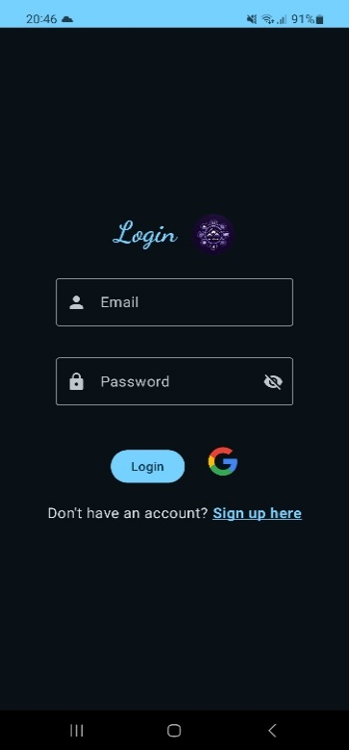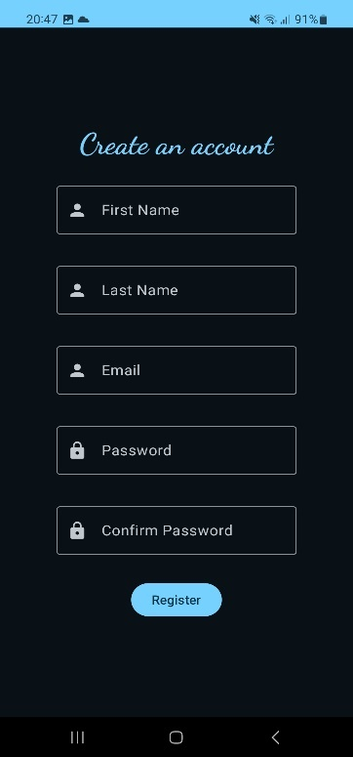Once the account creation process is complete, a success message and a button redirecting the user to the Login screen are displayed.

Figure 4‑1 Signup Screen

Figure 4‑2 Login Screen

#### Home Screen

The Home screen, as seen in Figure 4‑4, serves as the primary dashboard page for authenticated users. It is designed to provide an at-a-glance overview of the user's most critical task, prioritised based on due dates and user-defined importance levels.

The screen leverages reactive programming principles to ensure real-time updates as the user's task data changes. It maintains a persistent subscription to the user's task data, efficiently handling data synchronisation and conflict resolution.

A floating action button is strategically positioned on the screen, allowing users to quickly navigate to the Add Task screen and create new tasks.

#### Search Screen

The Search screen, presented in Figure 4‑3, enables users to locate specific tasks within their task list efficiently. It uses simple database queries that support partial matching on task titles, descriptions, and other relevant metadata, providing users with flexible and intuitive search capabilities.

Search results are displayed in a list or grid view, depending on the user's preferences and device characteristics.

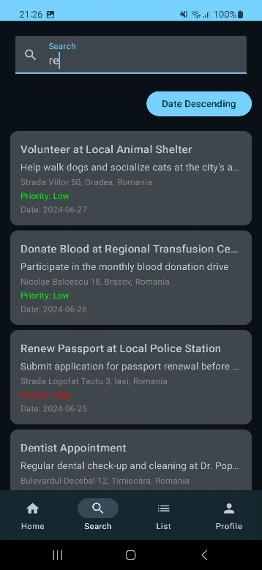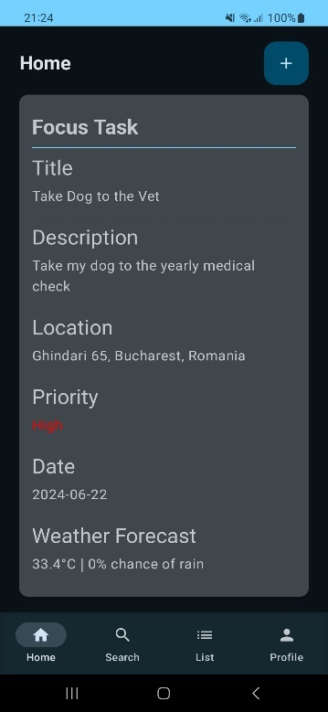Users can sort search results based on predefined criteria, such as priority or due date. This sorting functionality is implemented using yet again simple query conditions that leverage indexing and caching techniques to ensure optimal performance, even with large task datasets.

Figure 4‑3 Search Screen

Figure 4‑4 Home Screen

#### List Screen

The List screen, illustrated in Figure 4‑6, presents users with a comprehensive view of all their tasks, organised in a visually appealing and intuitive manner. It leverages advanced UI components and layouts to provide a consistent and responsive user experience across different device form factors and screen resolutions.

Each task is rendered as a card-like UI component, displaying essential information such as the task title, a truncated description (if the description exceeds a certain length), priority level represented by colour coding (e.g., green for low, orange for medium, red for high), and the temperature on the task's due date. These card components are designed to be interactive, allowing users to navigate to the Task Details screen by tapping or clicking on the card.

The List screen supports various user interactions, such as swiping gestures to mark tasks as complete or delete them and type marking to ensure every task belongs in a specific category.

To optimise performance and ensure a smooth user experience, the List screen implements efficient techniques such as lazy loading. These techniques minimise resource consumption and ensure that only the necessary data is loaded and rendered, resulting in improved responsiveness and battery efficiency.

#### Profile Screen

The Profile screen, presented in Figure 4‑5, provides users with a centralised location to manage their personal information and account settings. It displays the user's name, email address, task overview and profile photo, leveraging secure data retrieval from the Firebase server and caching mechanisms for improved performance.

Users can update their profile photo by tapping or clicking on the existing photo, which triggers a native file picker or camera interface, depending on the device's capabilities. The selected image is then uploaded to the Room database, ensuring data persistence.

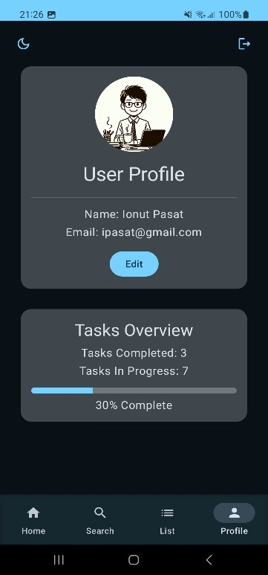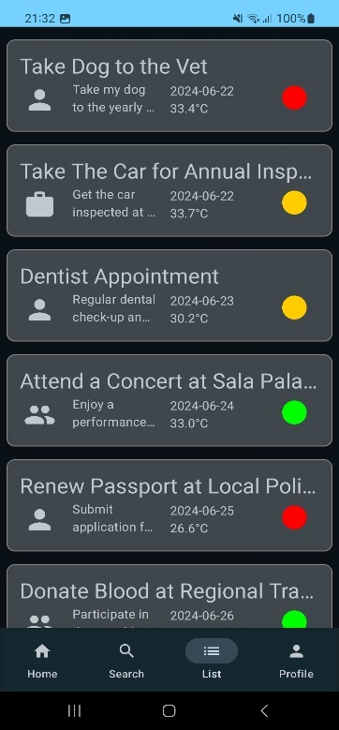The Profile screen also includes a theme and a logout button, which initiates a secure logout process by invalidating the user's authentication token and terminating the session on both the client and server sides.

Figure 4‑5 Profile Screen

Figure 4‑6 List Screen

#### Task Details Screen

The Task Details screen, as seen in Figure 4‑7, provides users with a comprehensive view of all the relevant details associated with a specific task. It fetches and displays information such as the task title, description, location, priority level, due date, and the temperature on the task's due date.

The screen leverages advanced UI components and layouts to present the task details in a visually appealing and easily consumable format.

A prominent button on the Task Details screen allows users to navigate to the Map screen, where they can view the task location in relation to their current location.

The Task Details screen also provides functionality for users to edit the task, ensuring they have full control over their task data. These actions are securely communicated to the device database, and appropriate data persistence and synchronization mechanisms are implemented to maintain the right flow of the application.

Figure 4‑7 Task Details Screen

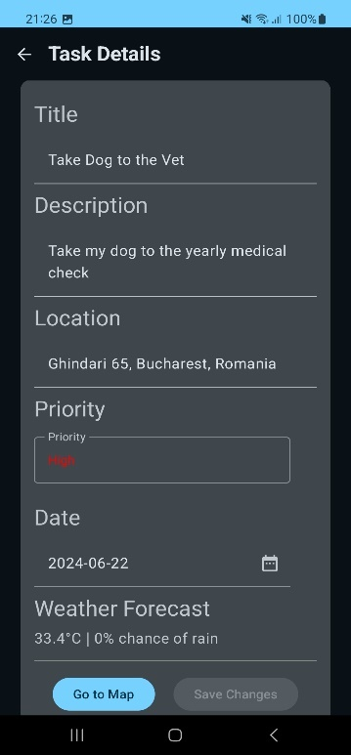

#### Add Task Screen

The Add Task screen, illustrated in Figure 4‑8, is a crucial component of the application, as it enables users to create new tasks and add them to their task list. It presents a user-friendly form with input fields for capturing the task title, description, location, priority level, and due date.

The input fields on this screen are equipped with client-side validation to ensure data integrity and adherence to predefined rules, such as non-empty fields, character limits, and date range validations.

The priority level selection is implemented using a dropdown menu UI component, providing users with a clear and intuitive way to assign importance levels to their tasks. The due date selection is facilitated by a date picker component that adheres to the application's design guidelines and supports accessibility features.

Upon successful form submission, the new task data is securely transmitted to the database for storage and integration with the user's existing task list.

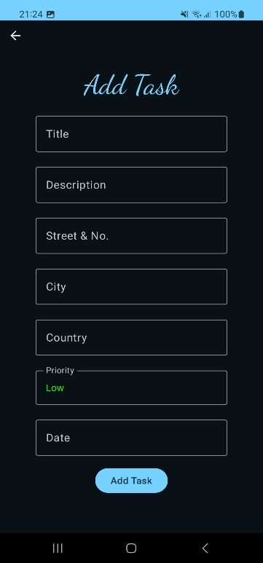

Figure 4‑8 Add Task Screen

#### Map Screen

The Map screen, presented in Figure 4‑9, is a critical component that enhances the application's functionality by providing geographical context and navigation assistance for task locations. It leverages powerful mapping libraries and APIs, such as Google Maps, to render an interactive and detailed map interface.

The screen displays two markers on the map: a blue marker representing the user's current location and a red marker representing the task location. These markers are dynamically positioned based on the user's device location and the task's location data retrieved from the backend server.

To facilitate navigation, the screen renders a polyline connecting the user's current location to the task location, representing the shortest path between the two points depending on the travel mode selected. This polyline is calculated using efficient routing algorithms and considers factors such as traffic conditions, road closures, and user preferences (e.g., avoiding tolls or highways).

A prominent button located in the bottom left corner of the screen opens the device's native mapping application (e.g., Google Maps) with the route pre-loaded and additional navigation details displayed, as seen in Figure 4‑10. This integration ensures a seamless transition between the application and the device's mapping capabilities, providing users with turn-by-turn navigation instructions, voice guidance, and additional features such as lane guidance, traffic updates, and alternate route suggestions.

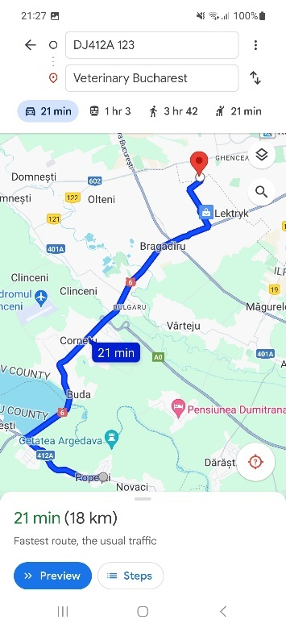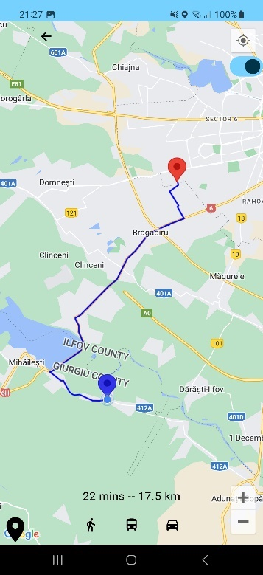

Figure 4‑9 Map Screen

Figure 4‑10 Google Maps Redirect

### Business Logic Layer

The business logic layer manages core functionalities and processes user inputs. Key components include:

* Task Manager: Handles operations related to task creation, modification, deletion, and prioritisation.
* Notification Manager: Manages the scheduling and delivery of notifications and reminders for tasks.
* Weather Service: Fetches real-time weather data for task locations, enhancing the task details with relevant environmental information.
* Navigation Service: Provides directions and maps, displays routes, and assists users in reaching task locations efficiently.

### Data Access Layer

The Data Access Layer (DAL) is a crucial component of the application's architecture, responsible for managing the storage, retrieval, and manipulation of data in an efficient, secure, and organized manner. [17]

#### Firebase Integration

The application integrates with Firebase, a comprehensive mobile and web application development platform, to leverage its robust authentication and real-time database capabilities. [18]

#### User Authentication

The Firebase Authentication SDK is utilised to provide secure and user-friendly authentication methods. Supported authentication methods include email/password and Google Sign-In, allowing users to choose their preferred authentication mechanism. Firebase's secure authentication flow ensures that user credentials and sensitive data are handled with industry-standard encryption and security protocols. Real-time data synchronisation keeps user authentication data up to date across devices and platforms. [18]

#### Secure Data Storage

Firebase's Cloud Firestore or Realtime Database is employed for the secure storage of user-profiles and related data. User profile information, including sensitive data like email addresses and profile images, is encrypted and stored securely in compliance with industry best practices. Data access is restricted and controlled through Firebase's robust security rules and access control mechanisms. [18]

#### Database Schema

The application's database schema is designed to efficiently support the core functionality of managing tasks and user profiles. It comprises two main entities:

##### Tasks Table

Defined by the Task data class, which serves as the entity representation.

Contains fields to store task details, such as title, description, priority, location (address and coordinates), and due date.

The id field is set as the primary key and is auto generated for each new task.

The schema is designed to support efficient querying, sorting, and filtering of tasks based on various criteria.

##### User Table

Defined by the User data class, representing user information.

Stores user-specific data, including email, name, and profile image URI.

The id field is set as the primary key and is auto generated for each new user.

The schema allows for easy retrieval and updating of user profile information.

#### Data Access Objects (DAOs)

The application follows the Repository pattern and utilises Data Access Objects (DAOs) to abstract the database interactions and ensure efficient data operations.

##### TaskDAO

Provides an interface for performing CRUD (Create, Read, Update, Delete) operations on tasks. Includes methods to add, update, delete, and retrieve tasks based on various criteria (e.g., priority, due date, location). Supports advanced querying and filtering capabilities, enabling efficient data retrieval.

##### UserDAO

Manages CRUD operations for user profiles, ensuring data integrity and security.

Provides methods to create new user profiles, update existing profiles, and retrieve user data.

Implements access control mechanisms to ensure only authorised users can access and modify their own profile data.

### Integration Layer

The Integration Layer facilitates the integration of the application with external services and APIs, enhancing the overall functionality and user experience.

#### Firebase Authentication

Firebase Authentication is a key integration component for managing user authentication and profile management.

It provides multiple authentication methods and supports both email/password and Google Sign-In authentication operations, giving users flexible options. Leverages Firebase's secure authentication flow and protocols to ensure the protection of user credentials and sensitive data. [18]

#### Weather API (Open-Meteo)

The integration with the Open-Meteo free and open-source weather API enhances the application's task management capabilities by providing real-time weather information for task locations. The application fetches current weather conditions, including temperature, for the specified task locations. Weather data is retrieved from Open-Meteo's API using secure and efficient HTTP requests. [19]

#### Enhanced Task Planning

By incorporating real-time weather data, users can make informed decisions about their tasks, considering factors such as outdoor activities, travel conditions, and potential weather-related obstacles.

The integration with Open-Meteo's API provides users with accurate and up-to-date weather information, improving their ability to plan and prioritise tasks effectively.

#### Map API (Google Maps)

The Google Maps API integration offers robust navigation and routing functionalities, making it easier for users to locate and navigate to their task locations. [20]

The application utilises the Google Maps API to display the user's current location and task locations on an interactive map.

Markers are used to represent the user's current position (blue marker) and the task location (red marker), providing a clear visual representation.

##### Routing and Navigation

The application calculates the shortest path between the user's current location and the task location using Google Maps' routing algorithms.

A polyline is rendered on the map, representing the calculated route, allowing users to visualize the path to their destination.

A prominent button is available, which opens the native Google Maps application on the user's device, pre-loaded with the start and end locations, and turn-by-turn navigation instructions.

This integration ensures a seamless transition between the application and the user's preferred navigation app, providing a comprehensive navigation experience.

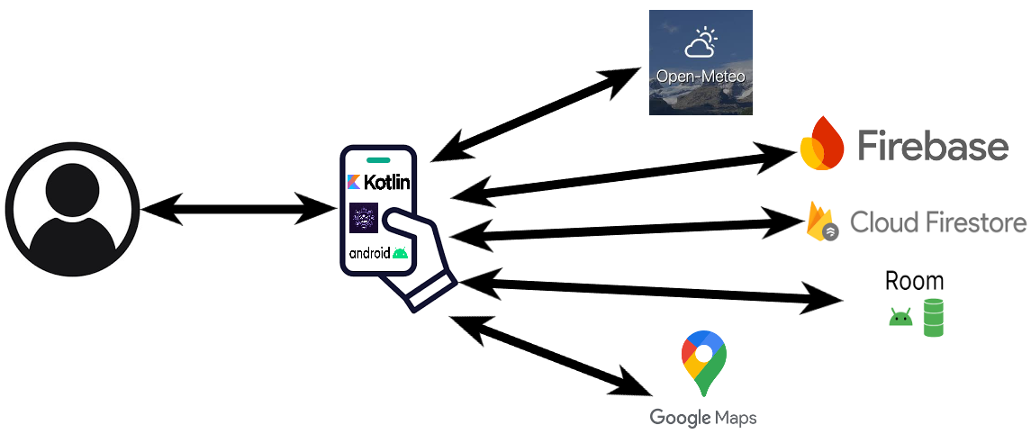These technical details and descriptions provide a comprehensive overview of the Data Access Layer and Integration Layer components within the application, which can be better visualised in Figure 4‑11, highlighting their roles, functionalities, and the technologies and services involved in ensuring efficient data management, secure authentication, and enhanced user experience through external integrations.

Figure 4‑11 Application networking [19, 29, 28, 23, 24]

## Process of Solution Development

The development process for the proposed solution follows an iterative approach, encompassing design, development, and testing phases:

Requirement Analysis: Collecting and analysing user requirements to define the application's features and functionalities.

Design Phase: Creating detailed design documents and diagrams to outline the architecture and structure of the application.

Development Phase: Implementing the application according to the design, with regular reviews and iterations to ensure alignment with requirements.

Testing Phase: Conducting comprehensive testing to identify and resolve issues, ensuring the application meets all specified requirements.

The proposed application effectively addresses the time management and task scheduling needs of users, as identified in the initial analysis of the thesis. By integrating a robust authentication system through Firebase, the app ensures secure and seamless access for users. The intuitive user interface, featuring a bottom navigation bar that transitions between Home, Search, List, and Profile screens, provides a streamlined user experience.

Overall, the proposed application not only meets but exceeds the initial user needs by offering a comprehensive, user-friendly, and feature-rich platform for time management and task scheduling. By combining essential functionalities with real-time data integration and intuitive navigation, the app positions itself as an indispensable tool for users aiming to optimise their productivity and manage their time effectively.

# Implementation Details

This chapter dives into the specific technical elements of the proposed solution, addressing challenges encountered during implementation and detailing how these were resolved. Furthermore, it elaborates on the usage of technologies introduced in the previous chapters, providing a comprehensive view of the development process.

## Firebase Integration

Firebase, a comprehensive app development platform provided by Google [18], was integrated into the application to handle user authentication and secure data storage. The integration followed these steps:

### Firebase Console Setup

The application was registered on the Firebase Console, a web-based platform for managing Firebase projects.

The SHA-1 fingerprint, a unique identifier for the app's signing certificate, was added to the Firebase project settings to ensure secure communication between the app and Firebase services. [21]

### Gradle Dependencies

The necessary Firebase dependencies from Snippet 5‑1 were added to the app-level build.gradle file, specifically for Firebase Authentication.

These dependencies enable the app to interact with the respective Firebase services and provide the required libraries and APIs. [22]



Snippet 5‑1 Firebase Dependencies

### Firebase Authentication

The functions that are used in the authentication process are implemented in the *FbViewModel* class, a ViewModel responsible for handling user authentication-related operations. This class is then injected with an instance of FirebaseAuth, a Firebase service that manages user authentication, as seen in Snippet 5‑2



Snippet 5‑2 FbViewModel class

Handling Sign-Up and Login: The onSignup and login methods initiate the sign-up and login processes. They update the state of the application based on the success or failure of these operations. The *inProgress* mutable state keeps track of whether an authentication operation is ongoing, while *signedIn* indicates whether the user is successfully signed in.

The *onSignup* method leverages the *createUserWithEmailAndPassword* method from FirebaseAuth to create a new user account with an email and password, as illustrated in Snippet 5‑3. The login method, on the other hand, is similar to the sign-up method but utilises the *signInWithEmailAndPassword* method from FirebaseAuth to authenticate existing users with their email and password credentials.

Both methods handle the authentication process asynchronously and update the app's state accordingly, providing a seamless user experience.

Additional functionality, such as error handling and state management, was implemented to ensure secure and reliable authentication processes.



Snippet 5‑3 Firebase Signup Function

## Notification Handling

Setting up notifications involves creating a notification channel, configuring a notification handler, and implementing a broadcast receiver to trigger notifications.[8]

### Gradle Dependencies

The necessary dependencies for notifications, Snippet 5‑4, were added to the app-level build.gradle file, specifically the core-ktx library from Android's Jetpack components. The core-ktx library provides utility classes and extensions for working with notifications and other Android system components.



Snippet 5‑4 Notification Dependencies

### Manifest Configuration

The required permissions, Snippet 5‑5, were added to the AndroidManifest.xml file, allowing the app to needed events from the system.



Snippet 5‑5 Notification Permissions

A broadcast receiver, ReminderReceiver, was declared in the AndroidManifest.xml file with the android:exported="true" attribute, enabling the receiver to handle broadcast intents from the system.

### Notification Setup

A notification channel, like the one in Snippet 5‑6, was created for the app, as required by Android 8.0 (Oreo) and above.

The createNotificationChannel method was implemented in the app's *onCreate* method, creating a *NotificationChannel* instance with a unique ID, name, and importance level.



Snippet 5‑6 Notification Channel

### Notification Handler

A *NotificationHandler* class, illustrated in Snippet 5‑7, was implemented to handle the creation and display of notifications. The *NotificationHandler* class utilises the *NotificationCompat.Builder* to create a notification with a title, message, and icon.

The *sendReminderNotification* method in the class is responsible for building and displaying the notification. The method incorporates various notification properties, such as priority, auto-cancel behaviour, and a unique ID to avoid notification duplication.



Snippet 5‑7 Notification Handler

### Broadcast Receiver

The *ReminderReceiver* class, extending *BroadcastReceiver*, was created to receive broadcast intents from the system.

The *onReceive* method of the class is called when a broadcast intent is received. In the *onReceive* method, an instance of the NotificationHandler class is created, and the *sendReminderNotification* method is called, passing the necessary data (e.g., title) obtained from the received intent. This approach allows the app to display notifications in response to system events or scheduled alarms, providing users with timely reminders or alerts for their tasks. By using the receiver described in Snippet 5‑8, an alarm can be scheduled so that the notification pops up at the requested time.



Snippet 5‑8 Broadcast Receiver

## Database Setup

To store and retrieve task and user data efficiently, the Room database library from the Android Architecture Components was integrated into the application. [23] The following steps were taken:

### Gradle Dependencies

The necessary Room database dependencies were added to the app-level *build.gradle* file.

These dependencies, Snippet 5‑9, include the room-runtime and room-compiler dependencies, which provide the required libraries and annotation processors for working with Room databases.



Snippet 5‑9 Room Dependencies

### Database Configuration

The database, Data Access Objects (DAOs), and entities were defined to structure the data storage and retrieval processes. The configuration presented in Snippet 5‑10 is used to define the database storage schema.



Snippet 5‑10 Room Database Config

### Database Entities

Two entities, Task and User, were created as data classes to represent the structure of the data stored in the database.

The Task entity contains fields for storing task details, such as title, description, priority, location (address and coordinates), and due date.

The User entity stores user-specific information, including email, name, and profile image URI.

Annotations from the Room library, such as @Entity and @PrimaryKey, were used to define the table structure and primary key for each entity.

*Data Access Objects (DAOs):*

Two DAOs, *TaskDao* and *UserDao*, were defined as interfaces to provide an abstract layer for interacting with the database.

The *TaskDao* interface, as presented in Snippet 5‑11, contains methods for performing CRUD (Create, Read, Update, Delete) operations on tasks, such as *insertTask*, *getAllTasks*, and *deleteTask*.

The *UserDao* interface, implemented in a similar manner as the task data access object, includes methods for managing user profiles, like *insertUser*, *getUserById*, and *deleteUser*.

Annotations from the Room library, such as @Dao, @Query, and @Insert, were used to define the database operations and map them to SQL queries.



Snippet 5‑11 Task Data Access Object

### Database Setup

An abstract class called Db was created (Snippet 5‑12), extending the *RoomDatabase* class from the Room library. The database class serves as the main access point for the app's database and provides methods to access the *TaskDao* and *UserDao* instances. The database version and entities were specified using annotations like @Database.



Snippet 5‑12 Database Class

By following these steps, the Room database was set up and integrated into the application, providing an efficient and organized way to store and retrieve task and user data while leveraging the benefits of the Room library, such as abstraction, query verification, and reactive data access.

## Maps and Weather API Integration

To provide navigation and real-time weather information for task locations, the application integrated the Google Maps API and a weather API (Open-Meteo) as follows:

### Google Maps Integration

A Google Maps API key was obtained from the Google Cloud Console, a web-based platform for managing Google Cloud services and APIs. [24]

The API key was added to the l*ocal.properties* file in the project, ensuring secure access to the Google Maps API while keeping the key separate from the codebase.

The necessary dependencies (Snippet 5‑13) for the Google Maps SDK were added to the app-level *build.gradle* file, including the play-services-maps dependency.



Snippet 5‑13 Maps Dependencies

These dependencies provide the required libraries and APIs for rendering maps, displaying markers, and implementing navigation features within the application.

### Weather API Integration

A *WeatherService* interface was implemented to define the API endpoint and parameters for fetching weather data from the Open-Meteo API, a free and open-source weather service. The Retrofit library, a popular HTTP client for Android, was used to make API requests and handle responses, made possible by adding the dependencies in Snippet 5‑14.



Snippet 5‑14 Retrofit Dependencies

The *WeatherService* interface defines the *getWeather* method, as in Snippet 5‑15, which takes parameters such as latitude, longitude, and date range to retrieve weather information for a specific location and time. The Retrofit instance was configured with the base URL of the Open-Meteo API and the necessary converters (e.g., *GsonConverterFactory*) to handle the API response format. This integration allows the application to retrieve real-time weather data for task locations, enhancing the user experience by providing relevant weather information for effective task planning.



Snippet 5‑15 Weather Service Interface

By integrating these APIs, the application can provide users with a seamless navigation experience by displaying task locations on a map and rendering the shortest path between the user's current location and the task location. Additionally, the weather API integration allows users to access real-time weather information for task locations, enabling them to plan their tasks more effectively based on weather conditions.

## Bottom Navigation Bar

A *BottomNavigationBar* composable function was created to render the bottom navigation bar. The composable function takes a *NavHostController* instance, and inside this composable, a list of *NavItem* objects was defined, representing the different destinations (Home, Search, List, Profile) to be displayed in the navigation bar. Each destination in the navigation bar was represented by a *NavBarItem*, which displays an icon label and handles the click event. The dependencies used to support navigation flow are illustrated in Snippet 5‑16



Snippet 5‑16 Navigation Dependencies

### Navigation Handling

The selected destination from the bottom navigation bar was tracked using a *mutableStateOf* variable, which stores the index of the selected item. When a *NavigationBarItem* is clicked, the corresponding index is updated in the *mutableStateOf* variable, triggering a recomposition, as to be seen in Snippet 5‑17. The *navController.navigate* function was called with the appropriate *NavItem* path, causing the application to navigate to the selected destination.



Snippet 5‑17 Bottom Navigation Controller

Additional configurations were applied to the navigate function, such as *popUpTo* to handle the back stack, *launchSingleTop* to prevent duplicating the destination in the back stack, and *restoreState* to preserve the state of the destination.

By implementing the bottom navigation bar using composable items, the application provides users with a consistent and intuitive way to navigate between different screens and functionalities. The use of composable functions and state management capabilities of Compose ensures a smooth and responsive user experience.

## Image Picker

To allow users to select and update their profile images, the application implemented an image picker functionality using the Android Activity library, for which the dependency described by Snippet 5‑18 was used.



Snippet 5‑18 Activity Dependencies

The implementation followed these next two steps:

### Image Picker Launcher

The *rememberLauncherForActivityResult* API from the Android Activity library was used to create a launcher for the image picker activity. The launcher is configured with the *ActivityResultContracts.PickVisualMedia* contract, which allows the user to select an image from the device's gallery or other available sources. The *onResult* lambda function was provided to the launcher, handling the result of the image picker activity, as seen in Snippet 5‑19.

### Image Selection and Handling

When the user selects an image from the image picker activity, resembled in Snippet 5‑19, the *onResult* lambda function is invoked with the selected image URI. If a valid URI is provided, the app requests read permission for the selected URI using the *contentResolver.takePersistableUriPermission* method. The selected image URI is stored in a state variable (*imageUri*) for further processing or display. The user's profile image URI is updated in the *userState* object, which represents the user's profile data. The *addUser* method from the *userVm* (*UserViewModel*) is called, passing the updated *userState* object to persist the user's profile image URI in the database or other storage mechanisms.



Snippet 5‑19 Image Picker Launcher

By implementing the profile image picker functionality, the application provides users with the ability to personalise their profiles by selecting and updating their profile images. The use of the Android Activity library and the *rememberLauncherForActivityResult* API simplifies the integration of the image picker activity and ensures a consistent user experience across different Android versions and devices.

## Polyline Rendering

The *decodePolyline* function is used to decode an encoded polyline string, which is a compact representation of a series of geographic coordinates, into a list of *LatLng* objects (a pair representing pairs of latitude and longitude). This functionality is commonly used when working with mapping APIs, such as the Google Maps API, to render polylines or routes on a map.

The encoded polyline string is a compressed format that represents a sequence of latitude and longitude coordinates using a specific encoding algorithm. The algorithm uses delta encoding and variable-length encoding to reduce the size of the string, making it more efficient for transmission and storage. [20]

The *decodePolyline* function, illustrated in Snippet 9‑1, takes an encoded polyline string as input and decodes it into a list of *LatLng* objects, which represent individual latitude and longitude coordinates. The function iterates through the encoded string, decoding the latitude and longitude values using a bitwise operation and variable-length decoding technique. It then creates *LatLng* objects from the decoded coordinates and adds them to a list, which is then used as an argument for the Polyline constructor from the Google Maps Android library that builds the polyline drawing, as seen in Figure 4‑9.

By implementing this *decodePolyline* function, the application can efficiently handle and process encoded polyline strings received from mapping APIs, allowing for the rendering of accurate and detailed polylines or routes on the map interface.

# Results Evaluation

This chapter aims to provide a comprehensive evaluation of the developed application, assessing its correctness, performance, and how it compares to existing solutions. The chapter addresses the following two fundamental questions:

* Does the application work correctly according to the specified requirements?
* How does the application’s performance compare to existing solutions in its niche?

## Correctness Evaluation

To evaluate the correctness of the application, we compare the implemented features against the requirements specified in Chapter 2. Each next section will specify the requirement set in Chapter 2 linked with the primary feature inside the application that provides it, as well as how it was tested.

### User Authentication

Requirement: Users should be able to sign up and log in using email and password.

Implementation: The *FbViewModel* class handles user sign-up and login using Firebase Authentication. The *onSignup* and *login* methods leverage Firebase’s authentication APIs to create new user accounts and authenticate existing users, respectively.

Evaluation: Extensive unit tests, like the ones in Snippet 9‑2 and Snippet 9‑4, were conducted to verify the reliability of the authentication process. Tests confirm that the application provides appropriate feedback for both successful and failed authentication attempts, ensuring secure access to user data. The implementation meets the specified requirements for user authentication.

### Task Management

Requirement: Users should be able to create, update, and delete tasks.

Implementation: The *TaskDao* interface and associated ViewModel methods (e.g., *insertTask*, *deleteTask*) enable complete CRUD operations for tasks. The Room database and associated entities (*Task*) are utilised to store and manage task data.

Evaluation: Rigorous testing, including unit tests (Snippet 9‑3), was conducted to validate the task management functionality. Tests confirm that tasks can be efficiently created, updated, and deleted within the application, meeting the specified requirements for task management.

### Notifications

Requirement: Users should receive notifications for scheduled tasks.

Implementation: The *NotificationHandler* class and *ReminderReceiver* broadcast receiver were implemented to set up and trigger notifications. The *NotificationHandler* class utilises the *NotificationCompat.Builder* to create and display notifications, while the *ReminderReceiver* handles broadcast intents and triggers the notification display.

Evaluation: Both manual and automated tests were conducted to validate the notification functionality. Tests confirm that notifications are received as scheduled, ensuring users are reminded of their tasks. The implementation meets the specified requirements for task notifications.

### Location and Weather Integration

Requirement: The application should integrate with Google Maps for location services and Open-Meteo for weather updates.

Implementation: Integration with the Google Maps API and Open-Meteo API was achieved through the use of Retrofit, a popular HTTP client library. The *WeatherService* interface defines the API endpoint for fetching weather data from Open-Meteo, while the LocationService interface facilitates integration with the Google Maps API for location-based services. [25]

Evaluation: Comprehensive testing, including unit tests (Snippet 9‑5), was performed to validate the location and weather integration. Tests confirm accurate retrieval and display of location and weather data, meeting user needs for location-based weather updates. The implementation meets the specified requirements for location and weather integration.

## Performance Evaluation

While precise metrics such as speed, resource consumption, and scalability are not the primary focus for an application in this niche, general observations based on informal benchmarking were made to assess the application’s performance compared to existing solutions:

### User Authentication Speed

The application’s user authentication speed, facilitated by Firebase Authentication, is comparable to industry standards for Firebase-based authentication solutions. The authentication process is efficient and does not introduce noticeable delays or performance bottlenecks.

### Task Management Efficiency

The CRUD operations for task management, implemented using the Room database and associated DAOs, are efficient. Tests indicate that the application interacts with the database promptly, ensuring smooth task management without significant performance degradation.

### Notification Reliability

Notifications are delivered promptly and reliably, thanks to the integration with Android’s notification system and the implementation of the NotificationHandler and ReminderReceiver classes. Users receive notifications as scheduled, meeting the application’s requirements for timely reminders.

### API Integration Performance

The application’s integration with the Google Maps API and Open-Meteo API, facilitated by Retrofit, exhibits quick response times. API requests are handled efficiently, ensuring that location and weather data are retrieved and displayed without significant delays.

### Resource Consumption

Informal benchmarking and testing indicate that the application’s memory and CPU usage are efficient compared to similar applications in the same niche. The application does not exhibit excessive resource consumption or performance issues during normal usage.

While detailed metrics and rigorous performance testing were not the primary focus of this project, these general observations demonstrate that the application performs well within its niche and provides a satisfactory user experience.

## Deployment Strategy

A clear deployment strategy was defined to ensure the smooth release and maintenance of the application, following industry best practices.

### Development and Testing

A continuous integration (CI) pipeline would be set up to automatically run the suite of automated tests on each code commit, ensuring early detection of issues and maintaining code quality. Regular code reviews and testing would be conducted to identify and address potential issues before deployment.

### Pre-Production

Before deploying to production, the application would be deployed to a staging environment for final testing and validation.

User acceptance testing (UAT) would be performed with a select group of users to gather feedback and ensure the application meets user expectations.

### Production Deployment

Firebase Hosting would be utilised to deploy the backend services and APIs, leveraging Firebase’s robust infrastructure and scalability.

The Android application would be deployed to the Google Play Store, following standard release procedures and guidelines. Post-deployment, the application’s performance would be monitored, and user feedback would be carefully analysed to address any issues promptly and plan future improvements.

By defining this deployment strategy, the application’s release and maintenance processes would be streamlined, ensuring a smooth transition from development to production and minimising potential risks or disruptions if the application were to be deployed. [26]

The developed application is a competitive solution within its niche, offering robust functionality and good performance. The evaluation has demonstrated that the application meets the specified requirements, providing users with a reliable and efficient task management experience, coupled with integrated location and weather services and profile management capabilities.

The strengths of the application lie in its reliable user authentication, efficient task management, prompt and reliable notifications, accurate location and weather data integration, and effective profile management. These strengths contribute to a positive user experience and fulfil the core objectives of the application.

While the application performs well within its niche, there are areas for improvement, such as conducting more extensive scalability testing, implementing enhanced user feedback mechanisms, exploring additional security measures, adding multiple device data synchronization and improving accessibility and localisation support. Future development efforts could focus on addressing these areas for improvement, further refining the application’s performance, security, and user experience. Continuous user feedback and adaptation to evolving user needs would be crucial in ensuring the application’s long-term success and relevance in the ever-changing technological landscape if it were to be deployed.

# Conclusion

## Summary of the Project

The project aimed to develop a comprehensive task management application integrating various functionalities to enhance user productivity and convenience. From the initial objectives to implementation and results evaluation, each phase of the project contributed significantly to achieving a robust and functional application. Each of the next section will provide the key points for every stage of this paper.

### Objectives

* Develop a user-friendly task management application.
* Implement secure user authentication.
* Provide efficient task management with CRUD operations.
* Integrate real-time weather data and location-based services.
* Implement notification functionality for task reminders.
* Provide a smooth and easy-to-use UI flow.

### Implementation

* User Authentication: Integrated Firebase Authentication to ensure secure and reliable user login and sign-up processes.
* Task Management: Utilized Room database for storing and managing tasks, ensuring efficient data operations.
* Notification System: Implemented notifications using Android’s NotificationManager and BroadcastReceiver.
* API Integrations: Connected with Google Maps API for location services and Open-Meteo API for weather updates using Retrofit.
* Profile Management: Enabled users to update their profiles and upload profile images using Android’s content resolver.
* User Interface: Developed a clean and intuitive UI with bottom navigation and user-friendly interactions.

### Results Evaluation

Functionality: Verified that all implemented features work correctly according to the requirements specified in Chapter 2.

Performance: Demonstrated satisfactory performance and reliability in delivering notifications, handling tasks, and fetching API data.

Testing: Conducted manual testing alongside unit tests to ensure robustness and reliability.

User Feedback: Validated the application with a small group of users, gathering valuable feedback for further improvement.

## Relevance and Quality of Results

The project successfully achieved its primary objectives, resulting in a functional and user-friendly task management application. The following points highlight the relevance and quality of the results obtained:

1. User Authentication: Ensured secure and seamless user access, meeting industry standards for authentication.
2. Task Management: Provided a reliable system for creating, updating, and deleting tasks, essential for effective task management.
3. Notification System: Implemented a robust notification system to remind users of upcoming tasks, enhancing user productivity.
4. API Integrations: Successfully integrated external APIs for weather updates and location services, adding valuable context to task management.
5. Profile Management: Enabled users to personalise their profiles, contributing to a more engaging user experience.
6. Performance and Reliability: Demonstrated satisfactory performance across all functionalities, with efficient resource usage and quick response times.

The application’s relevance is underscored by its comprehensive functionality, addressing common needs in task management while providing additional features such as weather updates and location-based services.

## Future Developments

While the project has achieved its primary objectives, there are several areas for further development to enhance the application’s functionality and user experience:

### Scalability

* Conduct extensive scalability testing to ensure the application performs well under high user load.
* Optimize database operations for better performance with larger datasets.

### User Feedback Integration

* Implement a formal feedback mechanism to gather user insights continuously.
* Use feedback to refine features and improve the user interface.

### Enhanced Features

* Add advanced task management features such as task categorisation, tagging, and prioritisation.
* Implement collaborative features to allow multiple users to manage tasks together.
* Integrate additional APIs to provide more contextual information (e.g., news, events).

### Cross-Platform Compatibility

* Develop versions of the application for iOS and web platforms to reach a broader audience.
* Add multiple device data synchronization
* Ensure seamless synchronisation of tasks and user data across different platforms.

### Performance Optimization

* Continuously monitor and optimise the application’s performance to reduce latency and improve user experience.
* Implement caching strategies to reduce API call frequencies and improve data retrieval times.

In conclusion, this project successfully developed a comprehensive task management application that meets the initial objectives and performs reliably. Implementing secure user authentication, efficient task management, real-time notifications, and API integrations demonstrates the project’s technical proficiency and attention to user needs. The positive feedback and satisfactory performance metrics validate the application’s relevance and quality. Moving forward, further development and optimisation can enhance the application’s capabilities and user experience, ensuring it remains a valuable tool for managing tasks and productivity.

# Bibliography

|  |  |
| --- | --- |
| [1] | S. Auld, “ACC Blog,” Australian Christian College, 25 March 2024. [Online]. Available: https://www.acc.edu.au/blog/time-management-skills-student-learning/. [Accessed 1 June 2024]. |
| [2] | MindTools, “What Is Time Management?,” [Online]. Available: https://www.mindtools.com/arb6j5a/what-is-time-management. [Accessed 1 June 2024]. |
| [3] | R. Gutung, “Importance of Time Management: 10 Benefits for Productivity Boost,” Medium, 22 June 2023. [Online]. Available: https://medium.com/@rajangu5045/importance-of-time-management-10-benefits-for-productivity-boost-c5b6e6cf5c83. [Accessed 15 June 2024]. |
| [4] | S. R. Covey, The 7 habits of highly effective people, Simon & Schuster, 2020. |
| [5] | D. Allen, Getting things done: The art of stress-free productivity., Penguin, 2015. |
| [6] | K. &. M. R. Ryu, “Evaluation of mental workload with a combined measure based on physiological indices during a dual task of tracking and mental arithmetic.,” *International Journal of Industrial Ergonomics,* vol. 35, no. 11, pp. 991-1009, 2005. |
| [7] | N. Mehta, “A Powerful Tool To Manage Your Time.,” LinkedIn, 27 March 2024. [Online]. Available: https://www.linkedin.com/pulse/powerful-tool-manage-your-time-nalin-mehta-ckqbf. [Accessed 15 June 2024]. |
| [8] | K. Haan, “Todoist Review (2024): Features, Pricing And More,” Forbes, 1 May 2024. [Online]. Available: https://www.forbes.com/advisor/business/software/todoist-review/. [Accessed 2 June 2024]. |
| [9] | J. Duffy, “Microsoft To Do Review,” PcMag, 8 August 2022. [Online]. Available: https://pcmag.com/reviews/microsoft-to-do. [Accessed 2 June 2024]. |
| [10] | J. Pot, “Google Keep Review,” PcMag, 22 December 2023. [Online]. Available: https://www.pcmag.com/reviews/google-keep-web. [Accessed 2 June 2024]. |
| [11] | Todoist, “Features,” Todoist, [Online]. Available: https://todoist.com/features. [Accessed 2 June 2024]. |
| [12] | Todoist, “Pricing,” Todoist, [Online]. Available: https://todoist.com/pricing. [Accessed 2 June 2024]. |
| [13] | Microsoft, “Microsoft To Do application,” Microsoft, [Online]. Available: https://www.microsoft.com/ro-ro/microsoft-365/microsoft-to-do-list-app. [Accessed 2 June 2024]. |
| [14] | A. Romero, “Here’s every feature in Google Keep and why it should be your go-to free notes app,” 9to5Google, 31 January 2023. [Online]. Available: https://9to5google.com/2023/01/31/what-you-can-do-google-keep/. [Accessed 15 June 2024]. |
| [15] | A. Developers, “Develop For Android,” Google, [Online]. Available: https://developer.android.com/develop. [Accessed 5 June 2024]. |
| [16] | Kotlin, “Kotlin Docs,” JetBrains, [Online]. Available: https://kotlinlang.org/docs/home.html. [Accessed 8 June 2024]. |
| [17] | baeldung, “Data Access Layer Explained,” baeldung, 18 March 2024. [Online]. Available: https://www.baeldung.com/cs/dal. [Accessed 10 June 2024]. |
| [18] | C. &. S. P. Khawas, “Application of firebase in android app development-a study,” *International Journal of Computer Applications,* vol. 179, no. 46, pp. 49-53, 2018. |
| [19] | Open-Meteo, “Features,” Open-Meteo, [Online]. Available: https://open-meteo.com/en/features. [Accessed 5 June 2024]. |
| [20] | G. Svennerberg, Beginning google maps API 3., Apress., 2010. |
| [21] | N. Smyth, Firebase essentials-Android edition., Payload Media, Inc., 2017. |
| [22] | A. Kumar, Mastering Firebase for Android Development: Build real-time, scalable, and cloud-enabled Android apps with Firebase., Packt Publishing Ltd., 2018. |
| [23] | A. Developers, “Save data in a local database using Room,” Google, [Online]. Available: https://developer.android.com/training/data-storage/room. [Accessed 5 June 2024]. |
| [24] | G. M. Platform, “Google Maps Platform,” Google, [Online]. Available: https://developers.google.com/maps/documentation. [Accessed 5 June 2024]. |
| [25] | V. Kaushal, “Retrofit in Android,” Medium, 28 November 2023. [Online]. Available: https://medium.com/@KaushalVasava/retrofit-in-android-5a28c8e988ce. [Accessed 5 June 2024]. |
| [26] | K. K. S. C. &. S. W. Luhana, “Streamlining mobile app deployment with Jenkins and Fastlane in the case of Catrobat's pocket code,” in *IEEE International Conference on Innovative Research and Development*, 2018. |
| [27] | S. Khan, “Draw route on google maps using poly-lines in Compose | Android Kotlin,” Medium, 19 March 2023. [Online]. Available: https://medium.com/@sahil3333/draw-route-on-google-maps-in-compose-android-kotlin-48cf283b98ea. [Accessed 3 June 2024]. |
| [28] | Firebase, “Cloud Firestore,” Google, [Online]. Available: https://firebase.google.com/docs/firestore. [Accessed 5 June 2024]. |
| [29] | Firebase, “Developer Documentation for Firebase,” Google, [Online]. Available: https://firebase.google.com/docs. [Accessed 5 June 2024]. |

# Appendices

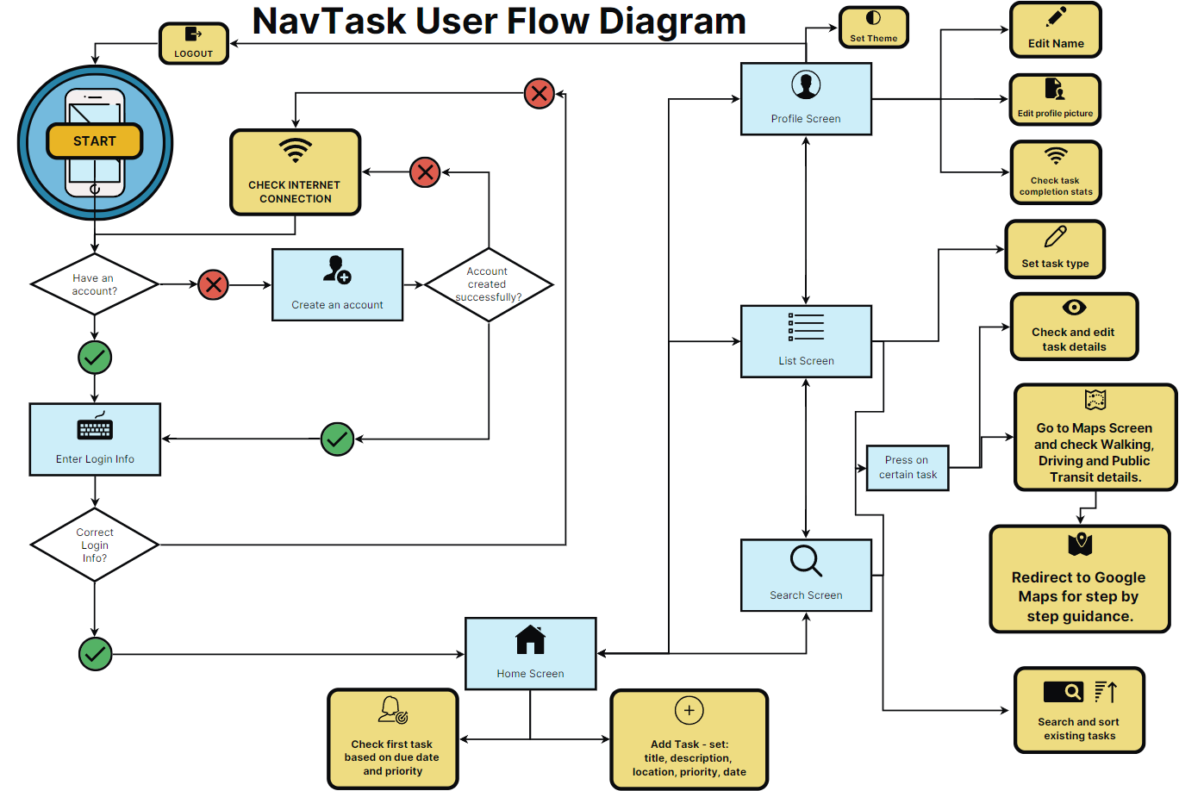

Figure 9‑1 Application workflow diagram[9]



Snippet 9‑1 Polyline Decoding [27]



Snippet 9‑2 Success Sign-up Unit Test



Snippet 9‑3 Task CRUD Unit Tests



Snippet 9‑4 User CRUD Unit Tests



Snippet 9‑5 Weather Retrieval Unit Test

1. <https://learning.stateofyouth.org/shortmodule/time-management/>
2. [Missing deadlines or important tasks? No bird’s eye view of your work?](https://www.convergedesign.com.au/missing-deadlines-or-important-tasks-no-overview-of-tasks-projects-work/)
3. <https://www.google.com/forms/about/>
4. [Link to Google Drive Research](https://drive.google.com/drive/u/0/folders/10ybDdiwdcsUizTkNZUsa7FkDYDitAz9h)
5. <https://get.todoist.help/hc/en-us>
6. <https://support.microsoft.com/en-us/todo>
7. <https://support.google.com/keep>
8. [Setting Up Notifications Using a Broadcast Receiver](https://meetpatadia9.medium.com/scheduled-local-notification-in-android-using-alarmmanager-3eefef512785)
9. Made using <https://infograph.venngage.com/infographics>